Project 2: Hypothesis Test and Regression Analysis
FIN 6307.501 - Mathematical Methods for Finance - F25

By Group 6
Priyadarshan Parida (PXP230068)
Sunayana Jana (SXJ230076)

Table of Contents
1. Introduction 3
2. Data and Methodology 3
Data Description 3
Daily Return Construction 3
3. Portfolio Construction 4
Equal-Weighted Portfolio 4
Optimal Portfolio 4
4. Hypothesis Tests 5
Comparison of volatility of daily returns 5
Comparison of mean of daily returns 7
5. Beta Estimation (Market Model) 8
Regression Model 8
Overall Model Goodness of Fit 10
Stock Volatility Relative to the Market (Testing $β1=1$) 12
Model Adequacy 14
6. Conclusion 19
References 20
Appendix 21

1. Introduction
This project builds on the analysis completed in Project 1 by taking a deeper look at how the two portfolios behave across key risk and return measures. We compare the portfolios using their daily return patterns, which allows us to evaluate differences in volatility, average performance, and overall risk behavior in a more detailed and consistent way. This helps reinforce or challenge the conclusions formed earlier about how these portfolios differ under normal market conditions.
Another goal of the project is to estimate betas for the individual companies included in our earlier analysis. Publicly available betas often use different assumptions, time windows, and market benchmarks, which may not match our specific context. By computing betas ourselves, using a clear and consistent modeling approach, we gain results that better fit our specific analysis and allow us to assess the adequacy of these models for portfolio comparison.

2. Data and Methodology

Data Description
Our analysis uses the same set of ten stocks selected in Project 1 and the same dataset assembled earlier. This dataset includes adjusted-close prices for the ten companies downloaded from NASDAQ, the S&P 500 Index obtained through the Yahoo Finance API, and the daily 13-week U.S. Treasury Bill series sourced from Federal Reserve Economic Data (FRED) using the same API.
The dataset covers the same date range as Project 1 to keep the results consistent across both projects. By using the original data, we ensure that all comparisons and follow-on analyses are based on a uniform and aligned set of inputs.

Daily Return Construction
Daily log returns were calculated for each of the ten companies using adjusted-close prices from the Project 1 dataset (from Oct 2020 to Oct 2025). For each stock $i$, let $P_{i,t}$denote its adjusted closing price on day t. The daily log return is:
$$R_{i,t}​=ln\left(\frac{​P_{i,t}}{P_{i,t-1}}​\right)$$
The same approach was used to compute daily log returns for the S&P 500 Index.
For the risk-free rate, we used the daily 13-week Treasury Bill yield series from Yahoo Finance. This yield is reported as an annualized rate, so each value was converted into a daily risk-free rate using the standard annual-to-daily formula, assuming 252 average trading days:
$$r_{daily}​={\left(1+r_{annual}​\right)}^{1/252}-1$$
Daily excess returns for each stock and for the S&P 500 were then obtained by subtracting the daily risk-free rate from their respective daily log returns. These excess returns are used in the volatility comparisons and beta estimation later in the project.

3. Portfolio Construction

Equal-Weighted Portfolio
The equal-weighted portfolio assigns the same weight to each of the ten selected companies. Since the stock list and dataset come directly from Project 1.
Let $R_{i,t}$ be the daily return of stock i on day t , and let there be $N=10$stocks. The equal-weighted daily portfolio return is:
$$R_{p,t}​=\frac{1}{N} \sum_{i=1}^{N}{R_{i,t}}$$
The equal-weighted portfolio provides a simple and transparent benchmark. It avoids reliance on estimated parameters and offers a clean baseline for comparing how the two portfolios behave in terms of daily return patterns and volatility.

Optimal Portfolio
The optimal portfolio weights were taken directly from Project 1. These weights were already computed based on the full dataset and are applied here without modification. Using the same set of weights ensures continuity and allows us to focus on analyzing the portfolio’s behavior, rather than recalibrating or redesigning the allocation.
As a recap, the ten-stock portfolio was optimized to maximize the Sharpe ratio, yielding the tangency portfolio on the efficient frontier. The optimization problem was formulated as:
$$\max_{w}{ \frac{w^{T}μ-r_{f}}{σ_{p}}} s.t. \sum_{i}{w_{i}=1, w_{i}≥0}$$
$${σ^{2}}_{p}=w^{T}×Ω×w$$
where $w$ is the weight vector, $μ$ is estimated using the sample mean of daily log returns. The numerator represents the portfolio’s expected excess return over the risk-free rate, while the denominator represents total portfolio volatility $σ_{p}$. $Ω$ is the covariance matrix of stock returns. The optimal long-only weight vector was computed using Python libraries.
The optimal portfolio is dominated by GS (57.6%), JPM (18%), WFC (16%), and SPG (8.4%). These weights reflect the solution to the daily Sharpe ratio optimization problem described above.
Optimal portfolio weight distribution:
Ticker | Weight
GS | 0.5764021
JPM | 0.1795652
WFC | 0.160036
SPG | 0.08399663
BAC | 2.4042E-17
O | 1.3974E-17
PLD | 2.1961E-18
BLK | 0.00E+00
AMT | 0.00E+00
AVB | 0.00E+00

4. Hypothesis Tests
The daily return series for both portfolios are used to test whether their risk and return characteristics differ in a statistically meaningful way. Two hypothesis tests are conducted: one comparing the volatility of daily returns, and another comparing their mean daily returns. We follow the hypothesis testing procedure taught in the class.

Comparison of volatility of daily returns
Hypotheses:
$$H_{0}: σ_{EW}^{2}=σ_{Opt}^{2}$$
$$H_{a}: σ_{EW}^{2}≠σ_{Opt}^{2}$$
where $σ_{EW}^{2}$ and $σ_{Opt}^{2}$ are the variances of the daily returns for the equal-weighted portfolio and optimal portfolio, respectively.
Test statistic and probability distribution:
We use a two-tailed F-test, which compares the ratio of the sample variances:
$$F=\frac{S_{EW}^{2}}{S_{Opt}^{2}}$$
This statistic follows an F-distribution with:
- $n_{1}-1$numerator degrees of freedom
- $n_{2}-1$ denominator degrees of freedom
where $n_{1}$and $n_{2}$are the number of daily observations in each portfolio.
Test statistic calculation:
We use Python and obtain the following values:
$$F\text{-}statistic=1.677$$
$$Two\text{-}tailed p\text{-value}=2.22×{10}^{-16}$$
$$Right\text{-}tail p\text{-}value (EW variance>OPT variance) = 1.11×{10}^{-16}$$
$$Left\text{-}tail p\text{-}value (EW variance<OPT variance) = \sim 1$$
95% confidence interval for the variance ratio $σ_{\text{EW}}^{2}/σ_{\text{OPT}}^{2}$ = [1.5011, 1.8733]

Significance level:
We use the standard significance level of 5%:
$$α=0.05$$Decision rule:
Reject $H_{0}$if:
- the F-statistic falls in the rejection region of the F-distribution, or
- $p\text{-value}<0.05$

Statistical Decision:
As the p-value is approximately 0 and < 0.05, we reject H₀ at 5% significance level. The data provides strong evidence that the two portfolios do NOT have equal variances.
Additionally, since the right-tail p-value is extremely small and the left-tail p-value is ~1, the evidence points strongly toward:
$$σ_{\text{EW}}^{2}>σ_{\text{OPT}}^{2}.$$
This is consistent with the confidence interval [1.5011, 1.8733] which lies fully above 1.
Economic/Investment Decision:
The equal-weighted portfolio exhibits higher daily volatility than the optimal portfolio, based on the confidence interval for the variance ratio. This means the optimal portfolio takes less risk and is more stable. This difference in volatility is economically significant and will influence portfolio selection trade-offs.

Comparison of mean of daily returns
Hypotheses:
$$H_{0}: μ_{EW}=μ_{Opt}​$$
$$H_{a}: μ_{EW}≠μ_{Opt}$$
where $μ_{EW}$and $μ_{Opt}$are the mean daily returns of the two portfolios.
Test statistic and probability distribution:
A two-sample t-test is used to compare the average daily returns of the two portfolios. Since the variance test showed unequal variances, we use the Welch t-test (unequal variances t-test).
Test statistic calculation:
We use Python and obtain the following values:
$$t\text{-}statistic=-0.8444$$
$$p\text{-value}=0.3985$$
Significance level:
We use the standard significance level of 5%:
$$α=0.05$$Decision rule:
Reject $H_{0}$if:
- the t-statistic falls in the rejection region of the t-distribution, or
- the p-value is less than 0.05.
Statistical Decision:
As the p-value (0.3985) is much larger than 0.05, we fail to reject H₀ at 5% significance level. There is no statistical evidence that the two portfolios have different mean daily returns.
Economic/Investment Decision:
The two portfolios earn similar average daily returns. Even though their volatilities are different, the mean return difference is too small to be statistically meaningful. This means neither portfolio consistently outperforms the other on a day-to-day basis in terms of average return. However, the equal-weighted portfolio delivers roughly the same daily returns while exhibiting higher volatility than the optimal portfolio, indicating that the optimal portfolio is more efficient.

5. Beta Estimation (Market Model)

Regression Model
We estimate beta for each stock using the standard market model applied to daily excess returns:
$$R_{i}- R_{f}=β_{0}+β_{1}\left(R_{m}-R_{f}\right)+ϵ_{i}$$where $R_{i}$ is the daily return of stock i, $R_{m}$ is the daily return for the market index S&P 500, and $R_{f}$is the daily risk-free rate.
Each stock is regressed individually on the same market excess return model over the same period.
Estimated betas for All Stocks:
Stock | $$β_{0}$$ | $$β_{1}$$ | t-stat ($β_{1}$) | p-value ($β_{1}$) | 95% CI for $β_{1}$ | R²
JPM | 0.000437 | 0.9069 | 27.39 | 1.08E-129 | [0.8419, 0.9718] | 0.375
BAC | 0.000157 | 0.9882 | 26.39 | 2.66E-122 | [0.9147, 1.0617] | 0.358
WFC | 0.00063 | 1.0294 | 23.49 | 2.34E-101 | [0.9434, 1.1153] | 0.307
GS | 0.000565 | 1.0918 | 32.41 | 1.05E-167 | [1.0257, 1.1578] | 0.457
BLK | –0.000058 | 1.206 | 44.39 | 5.03E-259 | [1.1527, 1.2593] | 0.612
PLD | –0.000257 | 0.9536 | 26.27 | 1.92E-121 | [0.8824, 1.0248] | 0.356
AMT | –0.000413 | 0.5385 | 13.34 | 4.56E-38 | [0.4593, 0.6176] | 0.125
SPG | 0.000385 | 1.0554 | 24.23 | 1.39E-106 | [0.9699, 1.1408] | 0.32
AVB | –0.000145 | 0.7202 | 22.22 | 2.12E-92 | [0.6566, 0.7838] | 0.283
O | –0.000251 | 0.4722 | 15.86 | 9.57E-52 | [0.4138, 0.5306] | 0.168

Estimated Regression Models:
$$JPM: \hat{R_{i}- R_{f}}=0.000437+0.9069\left(R_{m}-R_{f}\right)$$
$$BAC: \hat{R_{i}- R_{f}}=0.000157+0.9882\left(R_{m}-R_{f}\right)$$
$$WFC: \hat{R_{i}- R_{f}}=0.00063+1.0294\left(R_{m}-R_{f}\right)$$
$$GS: \hat{R_{i}- R_{f}}=0.000565+1.0918\left(R_{m}-R_{f}\right)$$
$$BLK: \hat{R_{i}- R_{f}}=-0.000058+1.206\left(R_{m}-R_{f}\right)$$
$$PLD: \hat{R_{i}- R_{f}}=-0.000257+0.9536\left(R_{m}-R_{f}\right)$$
$$AMT: \hat{R_{i}- R_{f}}=-0.000413+0.5385\left(R_{m}-R_{f}\right)$$
$$SPG: \hat{R_{i}- R_{f}}=0.000385+1.0554\left(R_{m}-R_{f}\right)$$
$$AVB: \hat{R_{i}- R_{f}}=-0.000145+0.7202\left(R_{m}-R_{f}\right)$$
$$O: \hat{R_{i}- R_{f}}=-0.000251+0.4722\left(R_{m}-R_{f}\right)$$
Interpretation of $β_{1}$:
The slope coefficient $β_{1}$ for each stock tells us how sensitive the stock is to market movements. The following key findings were noted based on the estimates from the regression model:
- Financial stocks (JPM, BAC, WFC, GS, BLK):
  - $β_{1}$ for all the stocks are close to or above 1, and highly statistically significant, meaning they broadly move with the market.
  - BLK has the highest $β_{1}$ (1.206) and shows above-market sensitivity.
  - GS also shows a high and significant beta (1.092).
- Real estate stocks (PLD, AMT, SPG, AVB, O):
  - $β_{1}$range from 0.47 to 1.06, all statistically significant.
  - AMT and O have significantly lower betas, meaning weaker sensitivity to the market.
  - SPG and PLD have $β_{1}$close to 1, indicating market-like behavior.

Interpretation of $β_{0}$:
For all 10 stocks, estimated $β_{0}$ values are very close to zero and not statistically significant.
This means the stocks, on average, do not earn excess returns beyond what is explained by their market exposure ($β_{1}$). This is consistent with CAPM, which predicts no persistent abnormal excess return after controlling for market risk.

Overall Model Goodness of Fit
R² (Coefficient of Determination):
The R² measures how much of the stock’s excess return is explained by market excess return. Higher R² indicates the market model explains a larger share of movements, while lower R² indicates stock returns are driven more by firm-specific or sector-specific factors.
ANOVA F-Test:
It tests whether the regression model is statistically meaningful overall. High F-statistic with a very small p-value provides strong evidence that the model explains variation in returns. Low F-statistic or large p-value indicates weak model.
Model Fit Summary for All Stocks:
Stock | R² | ANOVA F | ANOVA p-value
JPM | 0.375 | 749.99 | 1.08E-129
BAC | 0.358 | 696.31 | 2.66E-122
WFC | 0.307 | 551.92 | 2.34E-101
GS | 0.457 | 1050.5 | 1.05E-167
BLK | 0.612 | 1970.75 | 5.03E-259
PLD | 0.356 | 690.2 | 1.92E-121
AMT | 0.125 | 178.1 | 4.56E-38
SPG | 0.32 | 586.9 | 1.39E-106
AVB | 0.283 | 493.5 | 2.12E-92
O | 0.168 | 251.5 | 9.57E-52

Interpretation of Model Fit:
- Financial stocks (JPM, BAC, WFC, GS, BLK):
  - BLK has the strongest model fit (R² = 0.612), meaning the market explains more than half of its daily excess returns.
  - GS has a moderately strong fit (R² = 0.457), which along with the $β_{1}$ reflects its high market sensitivity.
  - BLK has the highest $β_{1}$ (1.206) and shows above-market sensitivity.
  - JPM, BAC, and WFC show moderate R² values (0.30–0.38), meaning the market explains roughly one-third of their return variation.
  - For all financial stocks, ANOVA p-values are effectively zero, indicating each regression model is highly significant
- Real estate stocks (PLD, AMT, SPG, AVB, O):
  - PLD and SPG show moderate model fit (R² around 0.32–0.36).
  - AVB shows a slightly lower R² (0.283).
  - AMT and O have the lowest R² values (0.125 and 0.168), meaning the market explains a relatively small portion of their movements. These stocks behave more independently from the broader market.
  - All ANOVA p-values are extremely small, confirming that the models are statistically meaningful even when R² is low.
Overall, the market model fits financial stocks better than real estate stocks. Despite differences in R², all models are statistically significant based on the ANOVA F-tests.

Stock Volatility Relative to the Market (Testing $β_{1}=1$)
Hypotheses:
For each stock, we test whether its market sensitivity ($β_{1}$) equals one:
$$H_{0}: β_{1}=1​$$
$$H_{a}: β_{1}≠1$$
Test statistic and probability distribution:
We use a two-sided t-test:
$$t=\frac{{\hat{β}}_{1}-1}{SE({\hat{β}}_{1})}$$
Under the null hypothesis, the test statistic follows a t-distribution with $n-2$degrees of freedom.
We also use the 95% confidence interval for $β_{1}$to confirm the decision.
Test statistic calculation:
The table below summarizes the results:
Stock | $$\hat{β_{1}}$$ | SE($\hat{β_{1}}$) | t-stat | p-value | 95% CI | Reject $H₀$? | Remarks Based on CI
JPM | 0.9069 | 0.0331 | -2.8121 | 0.005 | [0.8419, 0.9718] | Yes | $β₁$ < 1 is statistically supported (95% CI < 1)
BAC | 0.9882 | 0.0374 | -0.3155 | 0.7524 | [0.9147, 1.0617] | No | No evidence against $β₁$ = 1 (95% CI includes 1)
WFC | 1.0294 | 0.0438 | 0.6704 | 0.5027 | [0.9434, 1.1153] | No | No evidence against $β₁$ = 1 (95% CI includes 1)
GS | 1.0918 | 0.0337 | 2.7241 | 0.0065 | [1.0257, 1.1578] | Yes | $β₁$ > 1 is statistically supported (95% CI > 1)
BLK | 1.206 | 0.0272 | 7.5835 | 6.55E-14 | [1.1527, 1.2593] | Yes | $β₁$ > 1 is statistically supported (95% CI > 1)
PLD | 0.9536 | 0.0363 | -1.2791 | 0.2011 | [0.8824, 1.0248] | No | No evidence against $β₁$ = 1 (95% CI includes 1)
AMT | 0.5385 | 0.0404 | -11.4374 | < 1e-15 | [0.4593, 0.6176] | Yes | $β₁$ < 1 is statistically supported (95% CI < 1)
SPG | 1.0554 | 0.0436 | 1.2712 | 0.2039 | [0.9699, 1.1408] | No | No evidence against $β₁$ = 1 (95% CI includes 1)
AVB | 0.7202 | 0.0324 | -8.6311 | < 1e-15 | [0.6566, 0.7838] | Yes | $β₁$ < 1 is statistically supported (95% CI < 1)
O | 0.4722 | 0.0298 | -17.7261 | < 1e-15 | [0.4138, 0.5306] | Yes | $β₁$ < 1 is statistically supported (95% CI < 1)

Significance level:
We use the standard significance level of 5%:
$$α=0.05$$Decision rule:
Reject $H_{0}$if:
- $\left|t\right| >t_{0.975}$ , or
- the p-value is less than 0.05, or
- the 95% confidence interval does not include 1.
Statistical Decision:
We reject $H_{0}$for JPM, GS, BLK, AMT, AVB, O, at 5% significance level as their $β_{1}$ values are statistically different from 1.
We fail to reject $H_{0}$for BAC, WFC, PLD, SPG, as their $β_{1}$ values are statistically equal to 1, at 5% significance level.
Economic/Investment Decision:
Stocks with $β_{1}$ significantly less than 1 (JPM, AMT, AVB, O) are less volatile than the market. They respond less to market movements.
Stocks with $β_{1}$ significantly greater than 1 (GS, BLK) are more volatile than the market. They amplify market movements.
Stocks whose $β_{1}$ is not significantly different from 1 (BAC, WFC, PLD, SPG) move roughly with the market.
Overall, $β_{1}$differences are statistically meaningful for most stocks, especially in the real estate sector where several $β_{1}$are significantly below 1.

Model Adequacy
Test of Normality of Residuals (Visual Inspection and Jarque-Bera test):
The market model assumes that regression residuals are normally distributed.
We assess normality using:
- Visual inspection of residual histograms with overlaid symmetric bell curves
- Jarque–Bera (JB) test for formal statistical evaluation
Visual Diagnostic Results (Histograms): Based on the visual inspection of the histograms in Fig. 1 below, we note that:
- Distributions that are roughly centered around zero
- Noticeable skewness for many stocks
- Heavy tails in several cases (high kurtosis)
- Some stocks (e.g., SPG and AVB) exhibit extreme kurtosis or asymmetric tails
These visual patterns already suggest departures from normality.
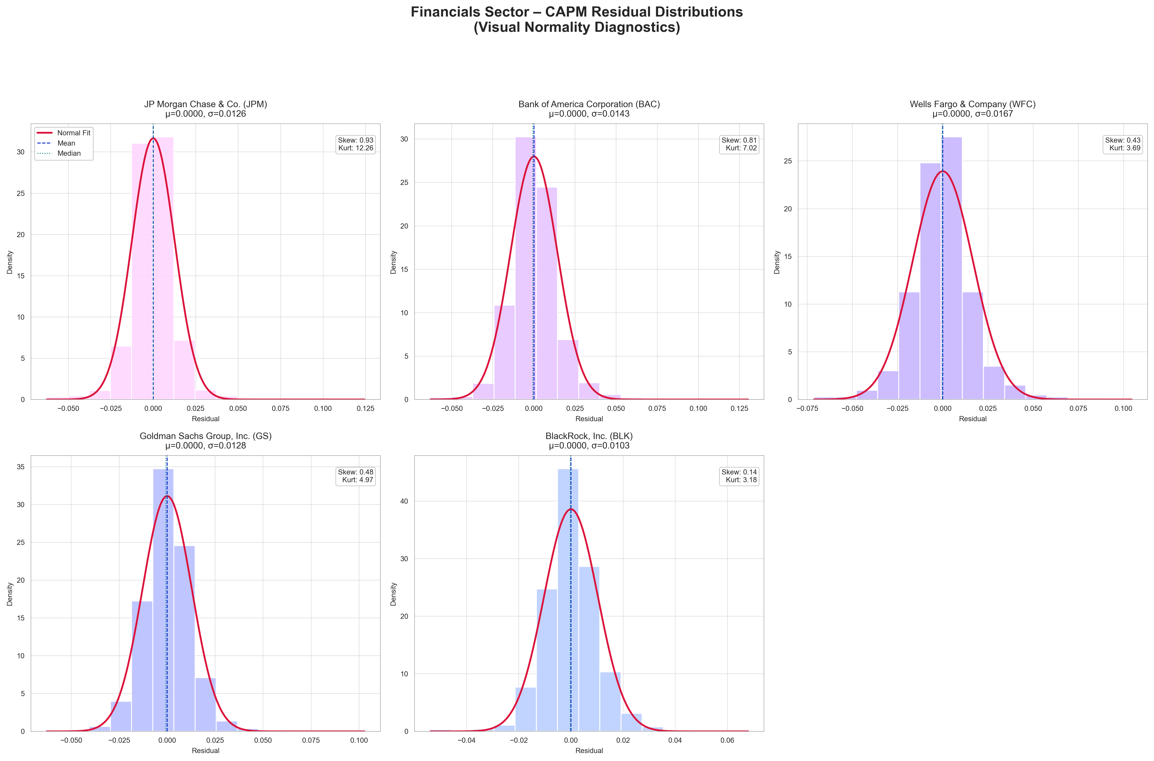
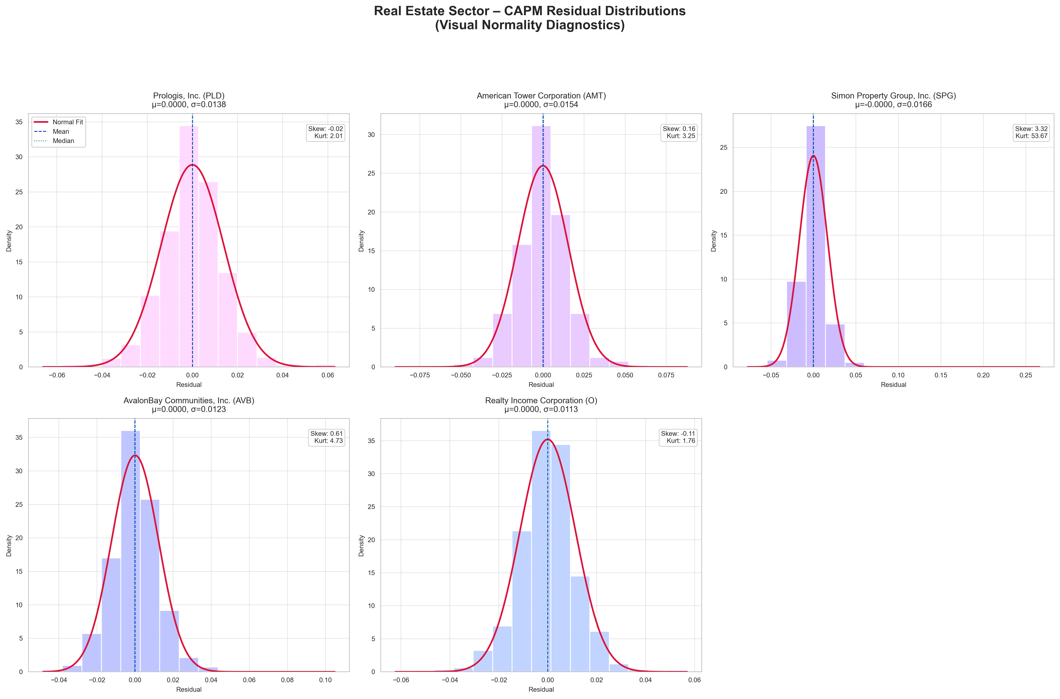
Fig 1: Residual distributions

Jarque–Bera Normality Test: The JB test evaluates whether residuals have skewness = 0 (symmetric), and kurtosis = 3 (normal tail thickness).
Hypothesis:
$H_{0}$ : Residuals are normally distributed
$H_{a}$ : Residuals are not normally distributed
Decision rule: Reject $H_{0}$ if JB p-value < 0.05
Results summary:
Stock | JB Statistic | JB p-value | Reject Normality (at 5%)?
JPM | 8012.52 | 0 | Yes
BAC | 2703.86 | 0 | Yes
WFC | 749.2 | 2.06E-163 | Yes
GS | 1332.58 | 4.31E-290 | Yes
BLK | 530.1 | 7.76E-116 | Yes
PLD | 211.31 | 1.3E-46 | Yes
AMT | 555.64 | 2.21E-121 | Yes
SPG | 152332.26 | 0 | Yes
AVB | 1241.5 | 2.58E-270 | Yes
O | 164.59 | 1.82E-36 | Yes

Statistical Conclusion: For all 10 stocks, the JB p-values are effectively zero, so we reject the null hypothesis of normality, at 5% significance level.
Economic Interpretation: Non-normal residuals do not invalidate the market model, but they indicate that daily stock returns have fat tails and asymmetry, which is common in financial data. Standard OLS is still unbiased, but Confidence intervals and Hypothesis tests may be less precise in small samples.
Test for Heteroskedasticity (Breusch-Pagan Test):
The market model assumes constant variance of residuals (homoskedasticity). If variance changes with the level of market returns, this assumption is violated. We use the Breusch-Pagan (BP) test to formally evaluate this.
Hypothesis:
$H_{0}$ : Residual variance is constant (homoskedasticity)
$H_{a}$ : Residual variance changes with the fitted values (heteroskedasticity)
Decision rule: Reject $H_{0}$ if BP p-value < 0.05
Results summary:
Stock | BP Statistic | BP p-value | Reject H₀ (at 5%)?
JPM | 1.739 | 0.1873 | No
BAC | 1.9947 | 0.1579 | No
WFC | 1.7928 | 0.1806 | No
GS | 0.8294 | 0.3624 | No
BLK | 5.0961 | 0.024 | Yes
PLD | 4.0189 | 0.045 | Yes
AMT | 0.6942 | 0.4047 | No
SPG | 1.1005 | 0.2942 | No
AVB | 1.9922 | 0.1581 | No
O | 0.0033 | 0.9545 | No

Statistical Conclusion: 8 out of 10 stocks do not show evidence of heteroskedasticity at the 5% level. We reject the null hypothesis for BLK and PLD, indicating signs of heteroskedasticity in their residuals. These two stocks may have variance that changes with the magnitude of market returns, consistent with their higher market sensitivity and stronger model fit.
Economic Interpretation: For most stocks, the variance of residuals appears stable, meaning the CAPM market model fits them without major issues related to heteroskedasticity. For BLK and PLD, the presence of heteroskedasticity suggests that their day-to-day risk may scale with market movements. Standard OLS inference may be less reliable unless robust standard errors are used for these stocks.
Test for Serial Correlation (Durbin–Watson):
The market model assumes that regression residuals are not autocorrelated over time. If residuals are serially correlated, this assumption breaks and may indicate model misspecification. We use the Durbin–Watson (DW) statistic to check for autocorrelation.
The DW statistic ranges between 0 and 4.
The critical values are d_{l} = 1.63 and d_{u} = 1.72
Hypothesis:
$H_{0}$ : No serial correlation ( $ρ=0$)
$H_{a}$ : $ρ≠0$
Decision rule:
DW < 1.63: Positive autocorrelation. We reject the null hypothesis that there is no autocorrelation.
DW > 1.72: No autocorrelation. We cannot reject the null hypothesis
1.63 < DW < 1.72: non-conclusive
Results summary:
Stock | DW Statistic | Interpretation
JPM | 2.07 | No autocorrelation
BAC | 1.925 | No autocorrelation
WFC | 2.039 | No autocorrelation
GS | 2.002 | No autocorrelation
BLK | 2.006 | No autocorrelation
PLD | 2.088 | No autocorrelation
AMT | 1.94 | No autocorrelation
SPG | 2.078 | No autocorrelation
AVB | 2.087 | No autocorrelation
O | 1.984 | No autocorrelation

Statistical Conclusion: For all 10 stocks, the DW statistic are greater than the d_{u} and hence there is no evidence of autocorrelation.
Economic Interpretation: Daily excess returns do not show residual patterns that persist over time. This supports the reliability of the OLS regression framework for estimating beta.
Model Adequacy Conclusion:
Overall, the diagnostics indicate that the market model provides a reasonable fit for estimating betas, but with some limitations typical of financial return data. Residual normality is rejected for all stocks, reflecting skewness and fat-tailed behavior that is common in daily equity returns. This does not bias the beta estimates but suggests caution when relying on statistical inference based on normality. Heteroskedasticity is generally not a concern with most stocks examined, with only BLK and PLD showing signs of non-constant variance. For these stocks, robust standard errors may improve inference. Finally, Durbin–Watson statistics show no evidence of autocorrelation for any stock, supporting the assumption of independent residuals. Taken together, the model assumptions hold well enough for beta estimation, and the market model remains appropriate for the purposes of this analysis.

6. Conclusion
Through both portfolio and stock-level analyses, the results show distinct characteristics of risk behavior while demonstrating the usefulness of the market model for estimating systematic risks. The equal-weighted and optimal portfolios were found to have statistically equal mean daily returns, but their volatilities were significantly different, with the optimal portfolio proving to be the more efficient of the two, which is expected as per design. For the individual stocks, estimated betas were in line with expectations: financial stocks generally moved closely with the market, while real estate stocks displayed more varied and often lower market sensitivity. Hypothesis tests for $β_{1}=1$ showed that only a subset of stocks behaved like “market-average” assets, emphasizing the importance of sector characteristics in driving systematic risk. Diagnostic tests revealed non-normal residuals and isolated cases of heteroskedasticity, but the absence of autocorrelation and the strong statistical significance of the regressions support the adequacy of the market model for beta estimation in this context. Overall, the analysis provides consistent evidence that systematic risk differs materially across assets and industrial sectors, and can be measured reliably using excess-return regressions, allowing investors to make more informed decisions about portfolio construction and risk exposure.

References
- ChatGPT.com Exploration & Research on https://chatgpt.com/
- NASDAQ Data Link. Historical stock prices for JPM, BAC, WFC, GS, BLK, PLD, AMT, SPG, AVB, and O. Retrieved from https://data.nasdaq.com/
- Yahoo Finance. S&P 500 Index (^GSPC) – Historical Data. Retrieved from https://finance.yahoo.com/quote/%5EGSPC/history
- Federal Reserve Bank of St. Louis (FRED) and Yahoo Finance. 13-Week Treasury Bill: Secondary Market Rate (DGS3MO). Retrieved from Yahoo API.
- S&P Capital IQ Pro. Company financials and market fundamentals for selected firms. Retrieved via institutional access (The University of Texas at Dallas).
- BlackRock, Inc. Annual Report and Investor Relations Data. Retrieved from https://www.blackrock.com/corporate/investor-relations
- Prologis, Inc. Investor Relations – Company Overview and Financial Reports. Retrieved from https://ir.prologis.com/
- AvalonBay Communities, Inc. Investor Relations – Company Financials. Retrieved from https://investors.avalonbay.com/
- U.S. Securities and Exchange Commission (SEC). EDGAR Company Filings. Retrieved from https://www.sec.gov/edgar/searchedgar/companysearch.html
- Investopedia. Sharpe Ratio, Portfolio Diversification, and Modern Portfolio Theory. Retrieved from https://www.investopedia.com/
- Hull, J. C. Options, Futures, and Other Derivatives (10th ed.). Pearson Education. (Reference for risk/return and Sharpe ratio concepts.)

Appendix
- Link to GitHub where our code is available: https://github.com/priyadarshanparida/market-model-fin6307
- Refer “Group6_Project2_Code_FIN 6307.501.pdf” for PDF export of the Jupyter Notebook file meant for code review
- Refer “Group6_Project2_Code_Package_FIN 6307.501.zip” for complete code (Jupyter Notebook) along input dataset, and output files packaged together in case you intend to run the code and review the output
- Stock Selection and Company Introduction:
Sector | Company | Ticker | Introduction
Financials | JPMorgan Chase & Co. | JPM | Leading U.S. bank; large balance sheet sensitive to rate spreads.
Financials | Bank of America Corp. | BAC | Retail and commercial exposure; strong net-interest income growth.
Financials | Wells Fargo & Co. | WFC | Major mortgage lender; affected by consumer-rate changes.
Financials | Goldman Sachs Group Inc. | GS | Investment bank: earnings tied to market and policy cycles.
Financials | BlackRock Inc. | BLK | Global asset manager; reflects investor flows responding to rate expectations.
Real Estate | Prologis Inc. | PLD | Industrial/logistics REIT; valuations linked to financing costs.
Real Estate | American Tower Corp. | AMT | Telecom infrastructure REIT; capital-intensive, debt-sensitive model.
Real Estate | Simon Property Group Inc. | SPG | Retail REIT. Interest rates influence consumer activity and property values.
Real Estate | AvalonBay Communities Inc. | AVB | Residential REIT. Higher mortgage rates shift demand toward rentals.
Real Estate | Realty Income Corp. | O | High-dividend REIT. Performance tracks Treasury yields closely.

